INTRODUCTION OF SWIFT: -

Society for Worldwide Interbank Financial Telecommunication
- SWIFT provides a network that enables Financial Institutions worldwide to send and receive information about financial transactions in a secure, standardized and reliable environment.
- SWIFT is a co-operative society under Belgian Law which was founded in Brussels(Headquarter) in 1973.
CUSTOMERS OF SWIFT
- Corporates, Investment Managers, Banks, Brokers/Dealers, Custodian, Banking Market Infrastructure and Security Market Infrastructure.

SWIFT enables secure exchange of proprietary data – reliability, confidentiality and integrity.

It also acts as the catalyst that brings the financial community together to work collaboratively to shape market practice, define standards and consider solutions to issues of mutual interest.

- SWIFT messaging standards: -
- MT (Text based messages)
- MX (XML based messages)
- SWIFT operates a number of services: -
FIN (Financial Application): - FIN is a SWIFT’s code store and forward messaging services. It is STP oriented, secure and reliable.
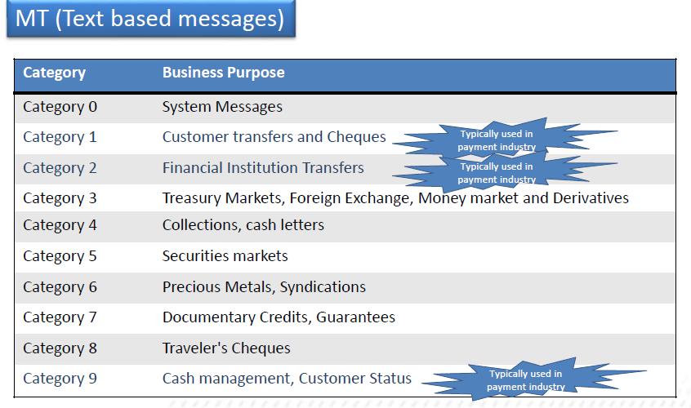
GPA (General Purpose Application): - It allows only system messages, i.e. message from user to SWIFT and vice – versa.

MX (XML Based Messages): - It allows exchange of financial messages represented in XML format. These messages types are developed in accordance with ISO 20022 standard.
Current syntax is as following: - xxxx.nnn.aaa.bb
xxxx - It Identifies the Business Process.
nnn - It identifies the particular fixed length of Message Functionality.
aaa - It identifies the particular variant of Message Functionality.
bb - It identifies the version.

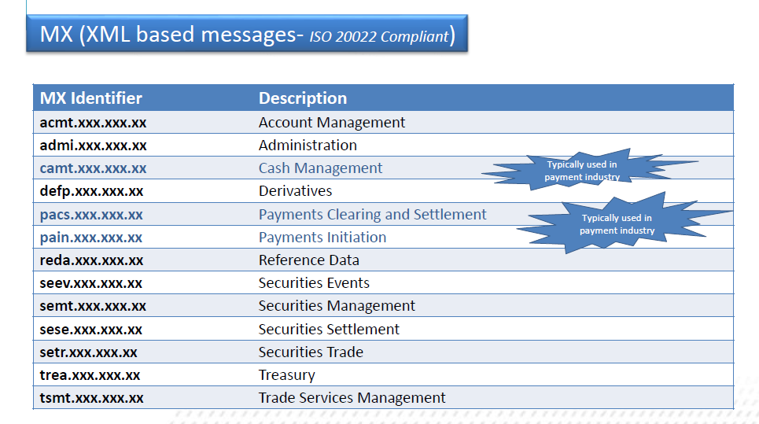
BIC – Business Identifier Code: -
- BIC codes are approved by ISO.
- It is a unique identification code for both Financial and Non Financial Institutions.
- 11 Char
- 4!a 2!a 2!c [3!c]
Bank Code Country Code Location Code Branch Code
Example: SBIN IN BB XXX
  - If 8th char is 0 it indicates that the BIC is a Test & Training destination.
  - If the 8th char is 1 it indicates that the Bank is not live on Swift.
  - If the 8th char is X it indicates that the CBT is not in the country but in some other country.

BEI - Business Entity Identifier: -
- BEI is only for Non-Financial Institution.
- 11 Char
- 4!a 2!a 2!c [3!c]
Entity Code Country Code Location Code Branch Code
Banks can register their Clients with Swift to help STP & uniform identification.
Example: Citibank can register iflex as their client
IFLX IN B1 XXX
IBAN –International Bank Account Number: -
- IBAN is an internationally agreed system of identifying bank accounts across national borders to facilitate the communication and processing of cross border transactions with a reduced risk of transcription errors.
- IBAN consists of BBAN (Basic Bank Account Number) whose format is decided by each national banking community.
- FR 16 0110 1250 0000 0001 2300 695
Country Code check digit BBAN

Block Structure of FIN Payment Message: -

A SWIFT MT Message may consist of: -
- {1: Basic Header Block}
- {2: Application Header Block}
- {3: User Header Block}
- {4: Text Block}
- {5: Trailers Block}
Only block 1 (the Basic Header block) is mandatory for all messages. Blocks 2-5 are optional and depend upon the nature of the message and on the application in which the message is being sent or received.

BASIC HEADER BLOCK: -
- Basic Header has the same format for both input and output messages, however the information contained in the basic header is related to sender when the message is input but relative to receiver when the same message is output.
- {1: F 01 BANKBEBBAXXX 2222 123456}
{1: F 01 BANKBEBBAXXX 2222 123456}
A B C D E F
  - A - Block Identifier
  - B – Application Identifier
It identifies the application within which the message is being sent or received.
F – FIN (User to User)
A – GPA (most GPA system messages and commands)
L – GPA (certain GPA session control commands, e.g. LOGIN, LOGIN acknowledgments, ABORT)
  - C - Application Protocol Data Unit Identifies
It identifies type of data that is being sent or received.
“01” identifier applies to all GPA and FIN system and user-to-user messages.
“21" for message acknowledgments such as ACK/NAK, UAK/UNK.

  - D - SWIFT/ LT Address
This 12-character SWIFT address, given in the basic header block, is the address of the sending LT (for input messages) or of the receiving the LT (for output messages), and includes the branch code. The 9th character indicates the LT ID.

  - "E" - Session Number
The session number identifies the session in which the message was transmitted. Within the basic header, the session number (four digits) is the user's current GPA or FIN session number. ("0000" - ISITC)
  - "F" - Sequence Number (ISN or OSN)
The sequence number always consists of six digits. It is the ISN of the sender's current input session or the OSN of the receiver's current output session.
Application Header Block: -
The application header is given in block 2 of a SWIFT message. If differs according to whether the message is a GPA or a FIN message and whether the application header is attached to an input message or to an output message.
  - Application Header - Input
For input messages, the application header describes the type of message, whom it is for and how it should be sent.
{2: I 100 BANKDEFFXXXX U 3 003}
A B C D E F G
"A" - Block Identifier
    - "B" - Input / Output Identifier
The input/output identifier consists of a single letter - either "I" for an input message or "O" for an output message.
    - "C" - Message Type
The message type consists of three digits which define the MT number of the message being input.
    - "D" Recipient's Address
This address is the 12-character SWIFT address of the recipient of the message, but with a Logical Terminal Code of "X". If defines the destination to which the message should be sent.
The system will replace the "X" with a specific Logical Terminal Code on delivery of the message.
    - "E" Message Priority
This character (used within FIN application headers only) defines the priority by which a message shall be delivered. The possible values are:
S = System
U = Urgent
N = Normal

Application Header Block – Output: -
For output messages, the output application header defines the type of message, who sent it (and when), and when it was delivered.
{2: 0 100 1200 910103BANKBEBBAXXX2222123456 910103 1201 N}
A B C D E F G H
  - "A” - Block Identifier
  - "B” - Input / Output Identifier
  - "C” - Message Type
Defines MT Number
  - "D” - Input Time (HH: MM)
"E” - Message Input Reference (MIR): - This is a string of 28 characters
which consists of the date the message was input (local to the sender).
        - The sender's LT identifier and branch code.
        - The sender's session number and sender's ISN.

    - "F" - Output Date
The output date (YYMMDD) is the date local to the receiver.
    - "G" - Output Time
The output time (HHMM) is expressed in the receiver's local time.
    - "H" - Message Priority

Text Block: -
The text of a SWIFT message (where applicable) is given in block 4 of a SWIFT message. An example of the text block in a typical FIN user-to-user message follows:
{4:
:20:PAYREF- TB54302
:32A:910103BEF1000000,
:50:CUSTOMER NAME
AND ADDRESS
:59:/123-456-789
BENEFICIARY NAME
AND ADDRESS
-}

- All Swift Text Messages have a maximum of 35 characters per line.
- In the event that the necessary information spans more than one line, the subsequent line must begin with the "//" continuation character.

Trailer Block: -
- Trailers are added to a message for control purposes: or to indicate that special circumstances apply to the handling of the message: or to convey special/additional information.
- Each trailer begins with a three letter code, followed by a colon, followed by the trailer information itself.
For example, block 5 of a user-to-user message, sent with an authentication
trailer and checksum trailer, may appear as:
{5: {MAC:41720873} {CHK:123456789ABC}}

MT 0XX: -
These are System messages and Service Messages.
•System messages relate to either the sending or receiving of messages used to customize a user's FIN operating environment.
For example:
•User-to-SWIFT messages (for example, Delivery Notifications, Retrievals)
•SWIFT-to-user messages (for example, Retrieved Messages, Non-Delivery Warnings)
•Service messages relate either to system commands (e.g. LOGIN, LOGOUT) or to acknowledgements (e.g. select ACK, NAK).

Ex. 02 Login Request
If the login is successful, then FIN returns a 22 Login Positive Acknowledgement.
If the login is unsuccessful, then FIN returns a 42 Login Negative Acknowledgement

MT 1XX: -
MT1XX Series is used for customer financial transfers i.e. Remitter or Beneficiary, or both parties, must be non-bank (Corporates, FIs, Retail, etc.)
The commonly used MT1XX types are given below.
•MT 103 – Single Customer Credit Transfer
•MT 103+ - Single Customer Credit Transfer (strict format for STP - indicated for ‘STP’ through Tag 119:)
•MT102 – Multiple Customer Credit Transfers
•MT104 – Direct Debit / Request for Debit Transfer
•MT101 – Closed User Group (CUG Message)

MT 2XX: -
MT2XX series is used for Inter-Bank Messages
Here both parties, Remitter and Beneficiary must be Banks (FIs)
The commonly used MT2XX types are given below.
•MT200 – Own Account Financial Transfer
•MT201 – Multiple Own Account Financial Transfer
•MT202 – General Financial Institution Transfer
•MT203 – Multiple General Financial Institution Transfer
•MT204 –Financial Market Direct Debit Message •MT210 – Pre-advice of Credit

MT 9XX: -

The MT9XX Series includes advices (Debit/Credit) and Reports (Balance, Account Statement)
The commonly used MT9XX types are given below.

•MT900 – Advice of Debit
•MT910 – Advice of Credit
•MT950 – (Account) Statement Message (Final/EOD)- Primarily for Inter-Bank Reconciliation
•MT940 – Customer Statement Message
•MT941 – Balance Report
•MT942 – Interim Transaction Report

MT202 COV: -

•Sent by or on behalf of the Ordering Institution directly, or through correspondent(s), to the financial institution of the Beneficiary Institution.
•Used only to order the movement of funds related to an underlying customer credit transfer that was sent with the cover method.
•The MT 202 COV must not be used for any other interbank transfer. For these transfers the MT 202 must be used. Both ordering customer and beneficiary details are included in MT202COV. MT 202 does not contain these details.

•To trigger the MT 202 COV format validation, the user header of the message (block3) is mandatory and must contain the code COV in the validation flag field 119 ({3: {119: COV}}).

Flow of Funds in a serial payment: -

Flow of funds in a cover payment – Scenario 1

Business Identifier Code- BIC – (issuing authority is SWIFT)

The Business Identifier Code is a unique identifier code representing a financial institution.

Business Entity Identifier (CORPORATES): -
BEI – Business Entity Identifier is a 11-character Identification Code for corporates.

4!a 2!a 2!c [3!c]
EntityCode CountryCode LocationCode BranchCode
BEI is only for Non-Financial Institutions.
Example: Citibank can register Infosys as their client
INFO IN B1 XXX

International Bank Account Number- IBAN: -

International standard for identifying bank accounts across national borders
•Originally adopted by the European Committee for Banking Standards (ECBS)
•IBAN consists of BBAN (Basic Bank Account Number) whose format is decided by each national banking community.
•BBAN must be of a fixed length and only case-insensitive alphanumeric characters are used.

Country | Example
France | FR16 0110 1250 0000 0001 2300 695
Australia | AU03 8000 0000 6080 1016 7519

MT Message Structure: -

SWIFT FIN messages conform to a defined block structure. Each block of a message contains data of a particular type and has a defined purpose.
Each block of message begins and ends with a curly bracket/ brace character "{" and "}”. The main blocks are numbered, and the block number is followed by a colon (:)
A typical SWIFT MT message may consist of:
• {1: Basic Header Block}
• {2: Application Header Block}
• {3: User Header Block}
• {4: Text Block}
• {5: Trailers Block}

Block 1 (the Basic Header block) is mandatory for all messages. Blocks 2-5 are optional and depend upon the nature of the message and on the application in which the message is being sent or received.

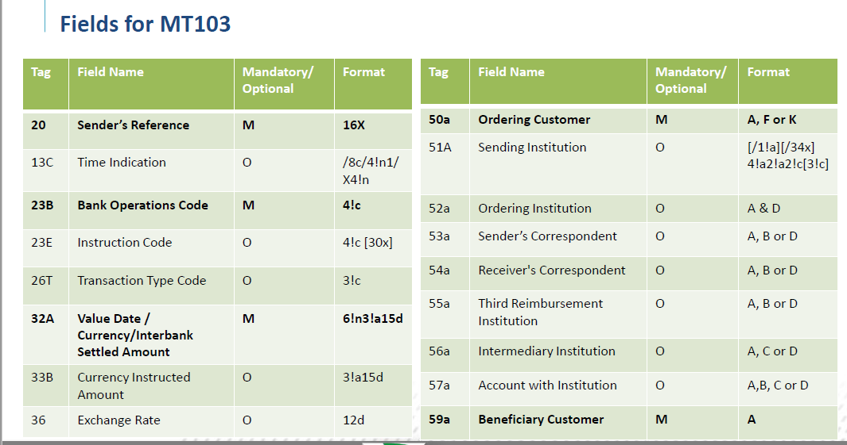

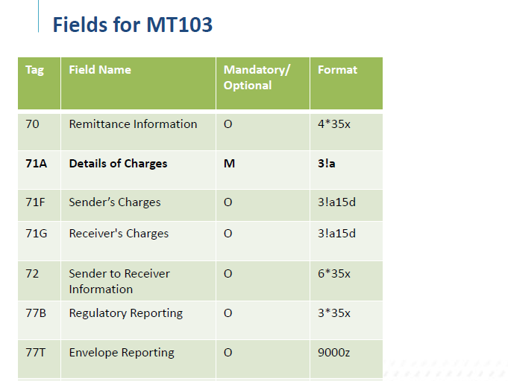
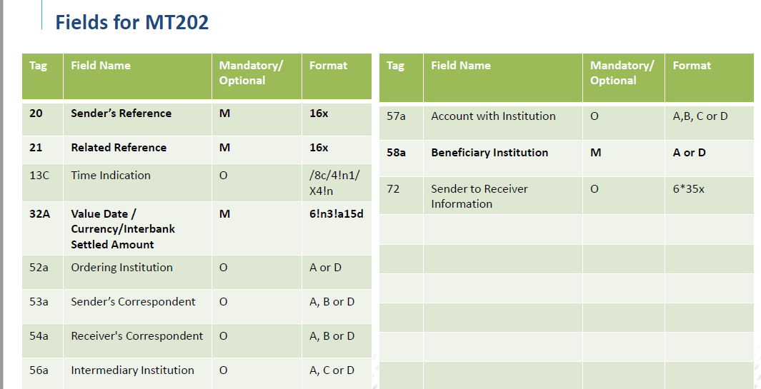

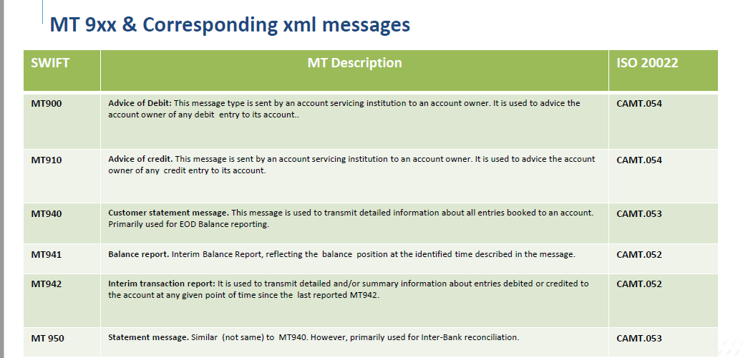

Business Scenario related to PI/SN: -
PI/SN processing takes place when the payment method is cover (i.e.) If the Sender and the Receiver have no direct
account relationship in the currency of the transfer then correspondent banks will be involved to cover the transaction. The MT 103 contains only the payment details and the Sender must cover the customer transfer by sending an MT 202 COV to the correspondent banks.

• PI is the Incoming payment instruction/pre advice with the correspondent chain which is assigned to MT 103. SN is the settlement notification/incoming cover which is assigned to MT 202COV, MT910.

